🧠 New Filter (Slice & Dice): Visual Layer Query Language (VQL)
New Slice & Dice - Query Behavior (Product spec)
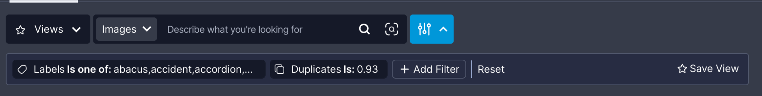

Overview
The new filter system in Visual Layer is powered by VQL — a type-safe, structured format designed to express filtering logic through the URL query parameter vql. This allows filters to be:
- Persisted and shareable via the URL
- Stateless in Redux – selected filters are not stored in global state
- Flexible to support various filter types (e.g. text, labels, issues, similarity)
The VQL format in the query param is the same as the format our APIs accept.

High-Level Architecture

State Management
- Redux holds:
  - All available metadata (e.g. list of tags, labels, folders)
- URL vql query param holds:
  - The currently active filters, encoded in a structured format
- Selectors:
  - Read both the Redux store and vql to compute selected filters and apply them to the UI and query logic

VQL Structure
VQL represents a list of filters in a URL-friendly, structured format. Each filter object includes:
- A unique ID
- The filter type (e.g. labels, issues, tags)
- The operation (e.g. is, one_of, contains)
- The values associated with it

Examples
- Label filter for is one of “cat” and “dog”:
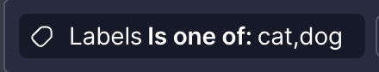
vql: [{"id":"1380bdd0-27dd-4d7a-ac33-bb3460c06deb","labels":{"op":"one_of","value":["cat","dog"]}}]
- Issue filter for “duplicates” with a threshold value:
vql: [{"id":"6b36f492-4b01-4e4a-9444-d01e61009677","duplicates":{"op":"duplicates","value":0.98}}]


Filter Creation Helpers
For constructing VQLs - helper functions are provided in the codebase for each filter type. Examples include:
- createLabelsFilter(labels, operator)
- createIssueTypesFilter(issueType, operator, confidenceRange)
- createTextFilter(text, operator)
These helpers ensure consistent structure, type safety, and proper operator mapping.

VQL Management in the App
Handled via the useVqlParams hook, which offers:
- vqlQueries — list of current VQL filters
- addVqlQuery(query) — add a new filter
- removeVqlQuery(id) — remove a filter
- updateVqlQuery(newQuery) — update a filter
- setVqlQueries(queries) — override all filters
- vqlToQuery(query) — convert VQL to the format used for backend queries

Example Usage
const { vqlQueries, addVqlQuery, removeVqlQuery } = useVqlParams();

const filter = createLabelsFilter(["cat", "dog"], "one_of");
addVqlQuery(filter);
removeVqlQuery(filter.id);


Best Practices
- Use UUIDs for filter IDs
- Only store selection state in the URL, never Redux
- Always use helper functions to build filters
- Keep the VQL format type-safe, structured, and readable

